Software Testing Assignment

Module–1(Fundamental)

q-1) What is SDLC

ans:- SDLC life cycle is the process that every software product has to go through its cycle to achieve an application

q-2) What is software testing?

Ans:- Software testing is the process of assessing and confirming the functionality of an application or software product.

Q-3) What is agile methodology?

Ans:- a collection of guidelines, attitudes, and methods that support software development teams in becoming better and cooperating to produce updates and new applications

q-4) What is SRS

ans:- Software's functionality, performance, and purpose are all outlined in its design. In terms of development, testing, and maintenance, it is a single source of truth for every development team.

q-5) What is oops

ans:- A paradigm in software engineering known as object-oriented programming (OOP) arranges software architecture around objects, or data, instead of functions and logic.

q-6) Write Basic Concepts of oops

ans:-  some basic concepts of object-oriented programming. Polymorphism, Inheritance, Encapsulation, Abstraction, Classes, Objects, Methods, Attributes

q-7) What is an object

ans:- data structure or abstract data type that contains fields and methods. Fields are state variables that contain data, and methods are subroutines or procedures that define the object's behaviour in code.

q-8) What is class

ans:- blueprint or prototype that defines the variables and methods common to all objects of a certain kind. For example, a bicycle is an instance of the class of objects known as bicycles

q-9) What is encapsulation

ans:- This is the process of wrapping up data and code into a single unit, called an object. This is to protect the data from being accessed by unauthorized code.

q-10) What is inheritance

ans:- This is the process of creating a new class that inherits the properties and methods of an existing class.

q-11) What is polymorphism

ans:- This is the ability of an object to take on many forms. For example, a dog object can be a pet, a guard dog, or a police dog.

q-12) Draw Usecase on Online book shopping

ans :- <https://lucid.app/lucidchart/6d830b3a-696a-43b4-9b67-4a826c45b97c/edit?viewport_loc=-940%2C-536%2C3330%2C1407%2C0_0&invitationId=inv_1050571d-3fcf-44c4-b6b4-22bc3481a26c> (lucid)

q-13) Draw Usecase on online bill payment system (Paytm)

ans:- <https://lucid.app/lucidchart/929f7ed1-8e8c-40c2-a552-c20481eedd0a/edit?view_items=GjozpOAB0e1V&invitationId=inv_6a63b80b-88c1-47d9-a147-0cabc186eb9c>

(lucid)

Q-14) Write SDLC phases with a basic introduction

Ans:- Software Development Life Cycle. It is a structured approach followed by software developers to plan, design, develop, test, and maintain software systems

* **Requirement collection**:- This phase involves gathering requirements of the software system.
* **Analysis:-** This phase involves assessing the feasibility of developing the software system.
* **Design:-** This phase involves designing the architecture and components of the software system.
* **Implementation:-** This phase involves writing the code for the software system.
* **Testing:-** This phase involves testing the software system to ensure that it meets the requirements.
* **Deployment:-**
* **Maintenance:-** This phase involves maintaining and supporting the software system after it has been deployed.

q-15) Explain Phases of the waterfall mode

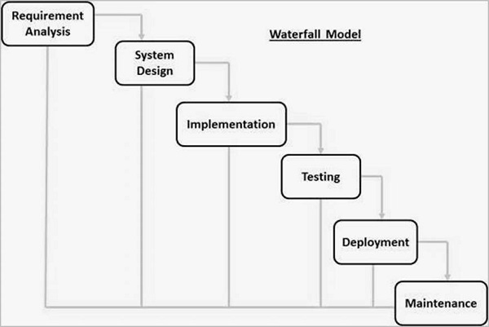

* **Project Analysis**: Review business perspectives, technical resources, and financial feasibility
* **Design**: Create a product design that addresses all requirements, constraints, and objectives. For IT-related products, the design is divided into logical and physical components.
* **Implementation**: Put previous planning into action
* **Testing**: Identify and fix errors and flaws, and polish the final product
* **deployment**: Release or hand over the fully functional product to the customer
* **Maintenance**: Optional phase for software projects that may require updates or improvements

Q-16) Write phases of spiral model

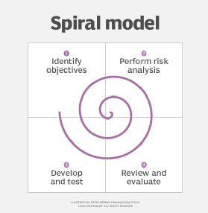

* Planning: Gather requirements and create a plan for the next iteration.
* Risk Analysis: Identify and evaluate the risks associated with the project.
* Engineering: Develop the software based on the requirements gathered in the previous iteration.
* Evaluation: Evaluate the software to determine if it meets the customer's requirements and if it is of high quality.

q-17) Write agile manifesto principles

ans:-

* Individuals and interactions over processes and tools.
* Working software over comprehensive documentation.
* Customer collaboration over contract negotiation.
* Responding to change over following a plan.

q-18) Explain working methodology of agile model and also write pros and cons.

Ans:-

The agile model is a project management approach that involves breaking the project into phases and emphasizes continuous collaboration and improvement. Teams follow a cycle of planning, executing, and evaluating.

Here are the pros and cons of the agile model:

**Pros:**

* Faster and flexible implementation of changes
* Better communication with users
* Greater user satisfaction
* Increased team productivity
* Improved quality of deliverables
* Reduced risk of project failure

**Cons:**

* Less emphasis on creating documentation
* Difficulty for new team members to understand the purpose and scope of a project
* Difficulty for the tester, who is in a continuous state of testing with few resources to provide an in-depth explanation of the project
* Can be challenging to manage complex projects
* Requires a high level of team commitment and collaboration

q-19) Draw usecase on Online shopping product using COD.